Instructions for Accessing itsLearning from any Device through the Browser (Safari, Chrome recommended)

1. Go to the Pine Street public website at http://pse.rockdaleschools.org/
2. On the top of the website, click on “Students.”

3. Under “Resources for Students,” lick on ItsLearning
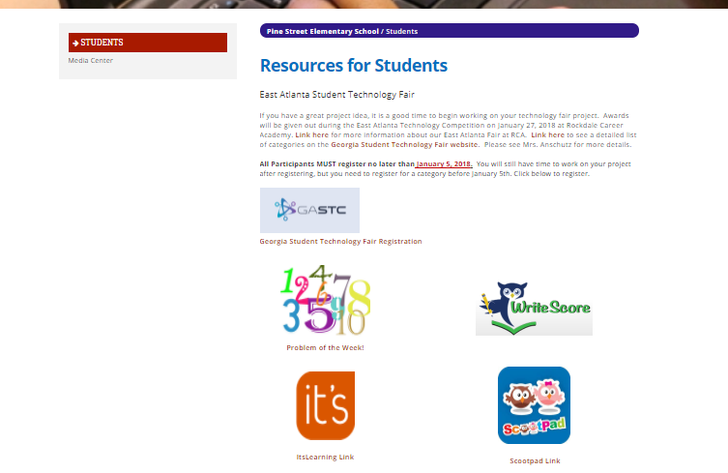

4. Click “log in with Rockdale County Public Schools Account”
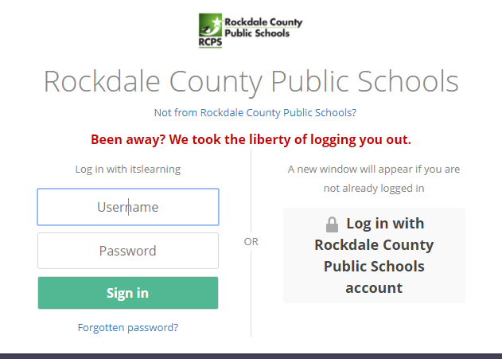

5. You will see a page like this:
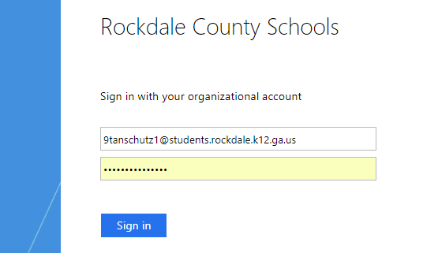

Login with:
Username: Student Rockdale Email - 9 + 1st Initial + Last Name + Unique Identifier@students.rockdale.k12.ga.us
Password: 9+ 1st Initial + Last Initial + Last 3-Digits of Student ID

6. Once you log in, click on “courses” then search for the course with your assignments.

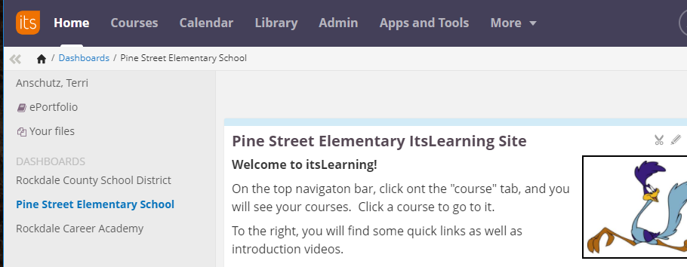

7. Complete the assignments as instructed by your teacher.

