Accessing ItsLearning Courses using the ItsLearning App

You may download the ItsLearning app to access online course materials and activities. Here are directions:
- Download ItsLearning app from GooglePlay or App Store.

- Click on the app, search for Pine Street Elementary and select.
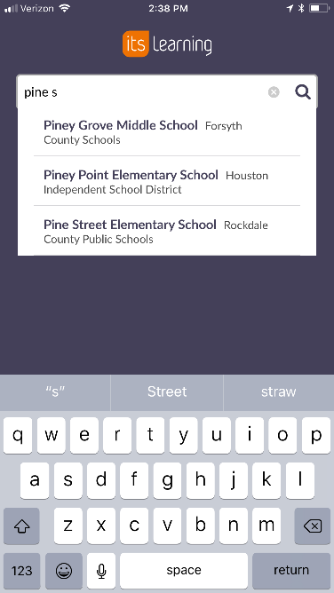

- Chose “external login,” click on Rockdale County Public Schools account, then login with credentials provided by your teacher. Remember that your username is followed by @students.rockdale.k12.ga.us
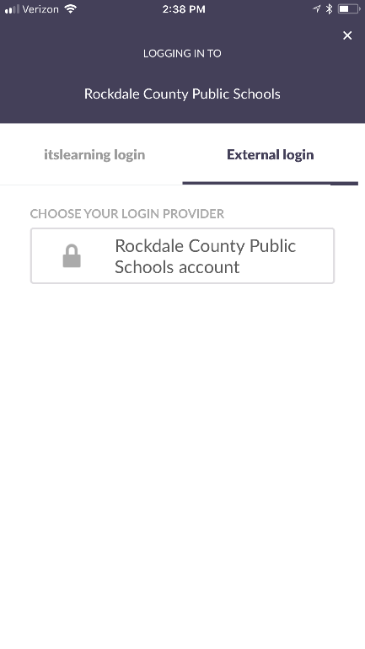
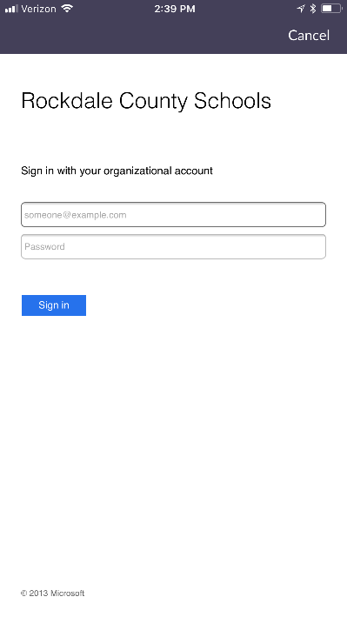

- Once you log in, click on the course you need to access for Independent Learning Day. Next, click on the Resources folder to see resources and activities for the course. Explore other tabs as well.
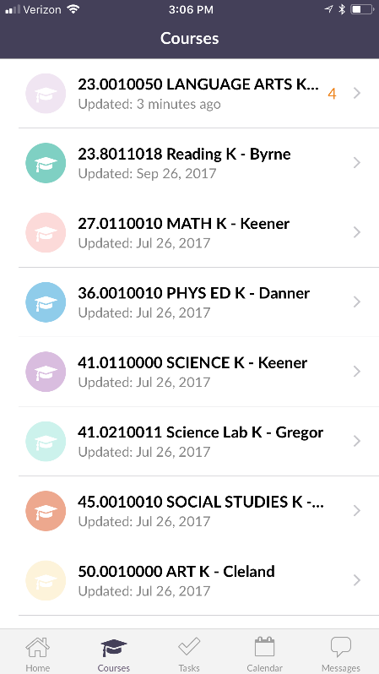
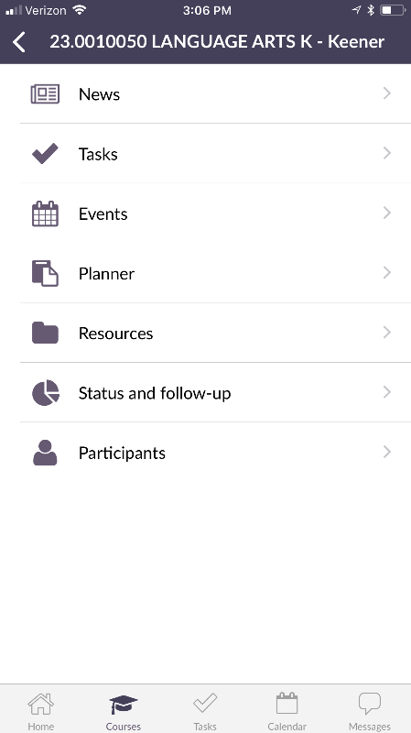

- Finally, access activities in the folder and have a fun day of learning!

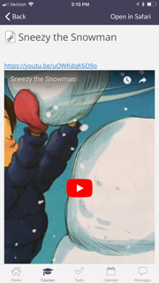
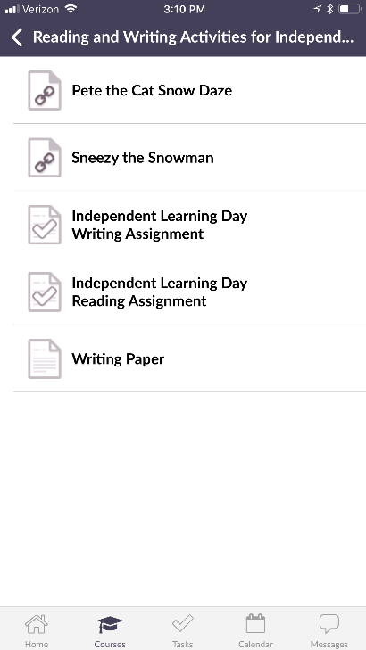

If you have any questions, please feel free to email your Digital Learning Specialist, Terri Anschutz, for guidance: tanschutz@rockdale.k12.ga.us

